**COLLEGE OF BUSINESS EDUCATION**



**DODOMA CAMPUS**

*Student’s Name:* **LEAH JOSHUA RUBEN**

Reg no: **03.5124.01.02.2023**

***Course* : BIT**

***Lecturer*:madam ATUPELE CAIRO MWAITETE**

***Subject:* PROGRAMMING IN JAVA**

***Nature of Work:* INDIVIDUAL ASSIGNMENT**

**Question.**

You are required to create a small Java application that addresses an everyday challenge faced by individuals or communities in Tanzania with a theme of **"Digital Solutions for Everyday Challenges in Tanzania"**. Each student should select a specific challenge and provide a software-based solution.

**Report on Online Voting System**

**Introduction**

The Online Voting System is a Java-based desktop application that I developed using Swing to create a graphical user interface (GUI). This system allows users to register their votes for predefined candidates while ensuring the integrity of the election by tracking voters and preventing multiple votes by the same individual.

**Features Implemented**

**1. User-Friendly Interface**

* I designed a clean and simple GUI using Java Swing.
* It allows easy navigation through different functionalities like voting and viewing results.

**2. Voter Validation**

* Each voter must enter their name before voting.
* The system checks if a voter has already cast their vote and prevents duplicate voting.

**3. Candidate Selection**

* The application displays a list of candidates with radio buttons, ensuring voters can select only one candidate at a time.

**4. Vote Casting**

* A "Vote" button lets voters submit their choice.
* After voting, a confirmation message appears.

**5. Results Display**

* A "Show Results" button displays the total votes each candidate received.
* The winner is highlighted along with the number of votes they received.

**Project Interface Screenshots**

**1. Welcome Screen**

The welcome screen prompts the voter to enter their name and provides instructions for voting.

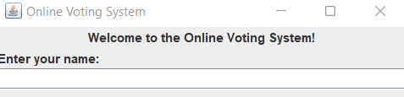

**2. Candidate Selection Screen**

The interface shows the list of candidates with radio buttons for selection.

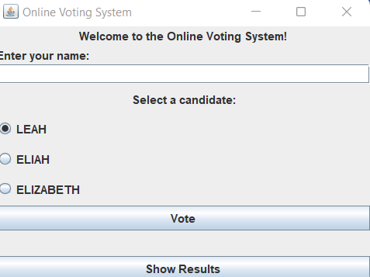

**3. Vote Confirmation**

When a voter casts their vote, a confirmation message is displayed.

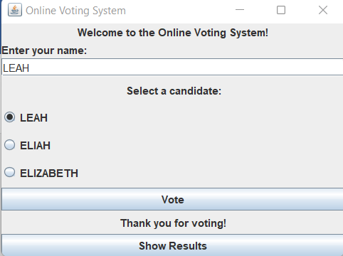

**4. Results Screen**

The results screen displays the total votes for each candidate and highlights the winner.

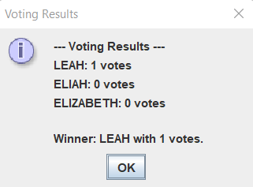

**Challenges Faced During Development**

**1. Designing the User Interface**

* Creating a responsive and intuitive interface took a lot of testing and iteration.
* I had to balance simplicity with functionality to ensure a smooth user experience.

**2. Voter Validation**

* Implementing a reliable mechanism to track voter names and prevent duplicate voting was a logical challenge.
* I needed to ensure real-time updates to the voter list without affecting performance.

**3. Data Handling**

* Managing the list of candidates and dynamically updating their vote counts required careful handling of data structures.

**4. Error Handling**

* I addressed issues like invalid input, null selections, and empty names to make the system robust.

**5. Testing and Debugging**

* Debugging GUI-based applications took time since real-time interaction and validation were required.
* I performed iterative testing to identify and fix edge cases.

**Conclusion**

The Online Voting System demonstrates how Java Swing can be used to build interactive desktop applications. By overcoming various challenges and focusing on user experience, I was able to create a simple, secure, and reliable voting system.

This project can be further improved by adding advanced features like voter authentication using unique IDs, real-time vote tally updates, and database integration for better data management.